My eCommerce Project

Project Manager: Raul C Bozan

horizontal line

## **Contents**:

**INTRODUCTION**

**Project Overview + Research ………………………………… (Page 2)**

* **Requirements Definition**
* **Determining Specifications**
* **Development Approach**
* **Installation Method**
* **Development Decision**

**DESIGN**

**Design Documentation ………………………………………… (Page 3)**

* **Timeline - Gantt Chart**
* **Site Map & Storyboards**
* **Flowchart**
* **Database Schema**
* **Data Dictionary**

**IMPLEMENTATION/TESTING**

* **Coding**
* **Code Optomisation**
* **Testing**

**PROJECT LOG** - continuously updated throughout the project

**INTRODUCTION**

**Project Overview + Research:**

This project *… Esim Site*

**Requirements definition** - *I am creating an Ecommerce site to give people the opportnumity to access a vast range of different esim packages that can be used in many countries. It solves the problem of travellers only be limited to physical sim cards that comes with a wide range of problems like accessibility,language, and cost.*

**Determining specifications** - *what must the system do/perform?* The site must have functionality for: Login, Products, Product_Stock_Level, Shopping Cart, Payment and Order_History. The site should support RBAC and utilise a secure login.

**Development Approach**

Research the Agile, Waterfall and WAgile development approaches - decide which one to adopt - document your findings (description/advantage/disadvantage)

Agile -

Waterfall -

WAgile -

The development approach I will use is …

**Installation method**

Research installation method approaches - Direct, Phased, Parallel or Pilot - decide which one to adopt - document your findings. (description/situation suitable for)

Direct -

Phased -

Parallel -

Pilot -

The installation method I will use is …

**Development Decision** - I considered the following alternatives to developing the site myself -

Research alternatives to developing the site - 3rd party tools(RAD, etc), outsourcing, etc

**DESIGN**

**Design Documentation:**

**Timeline - Gantt chart**

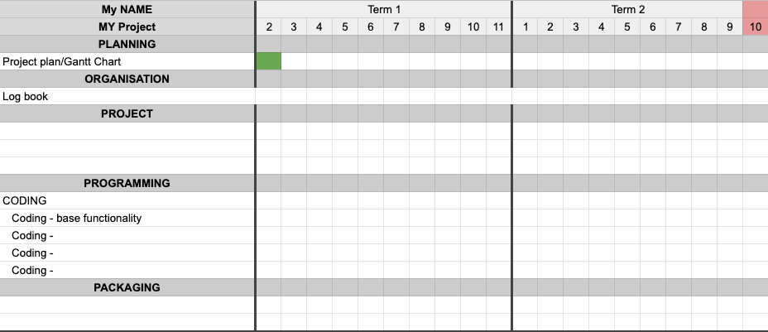

**(FYI only)**

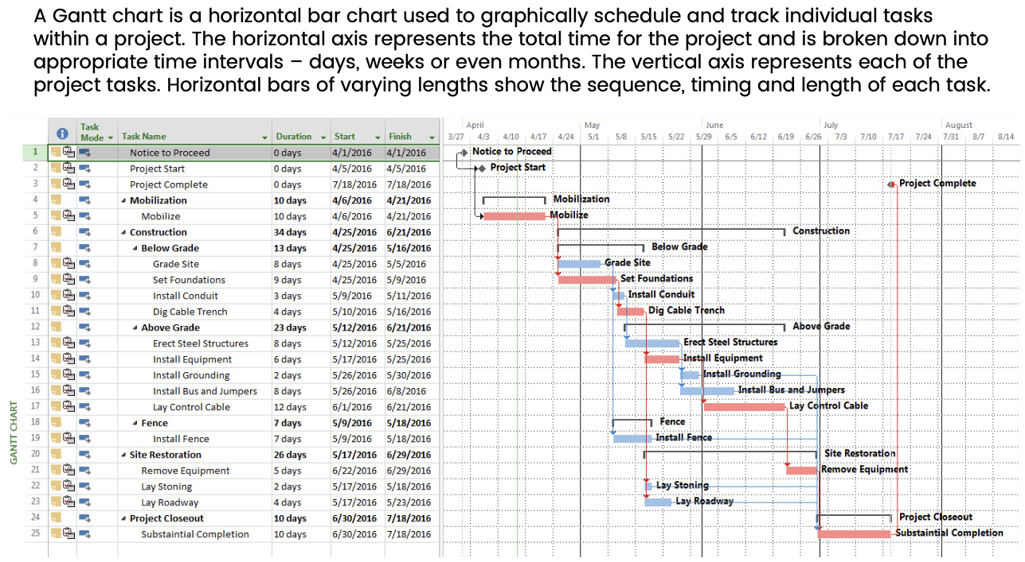

**Site Map & Storyboards**

Create a site map & storyboards for your game to showcase your interface (you may provide an image of hand-drawn storyboards/user draw.io/etc)

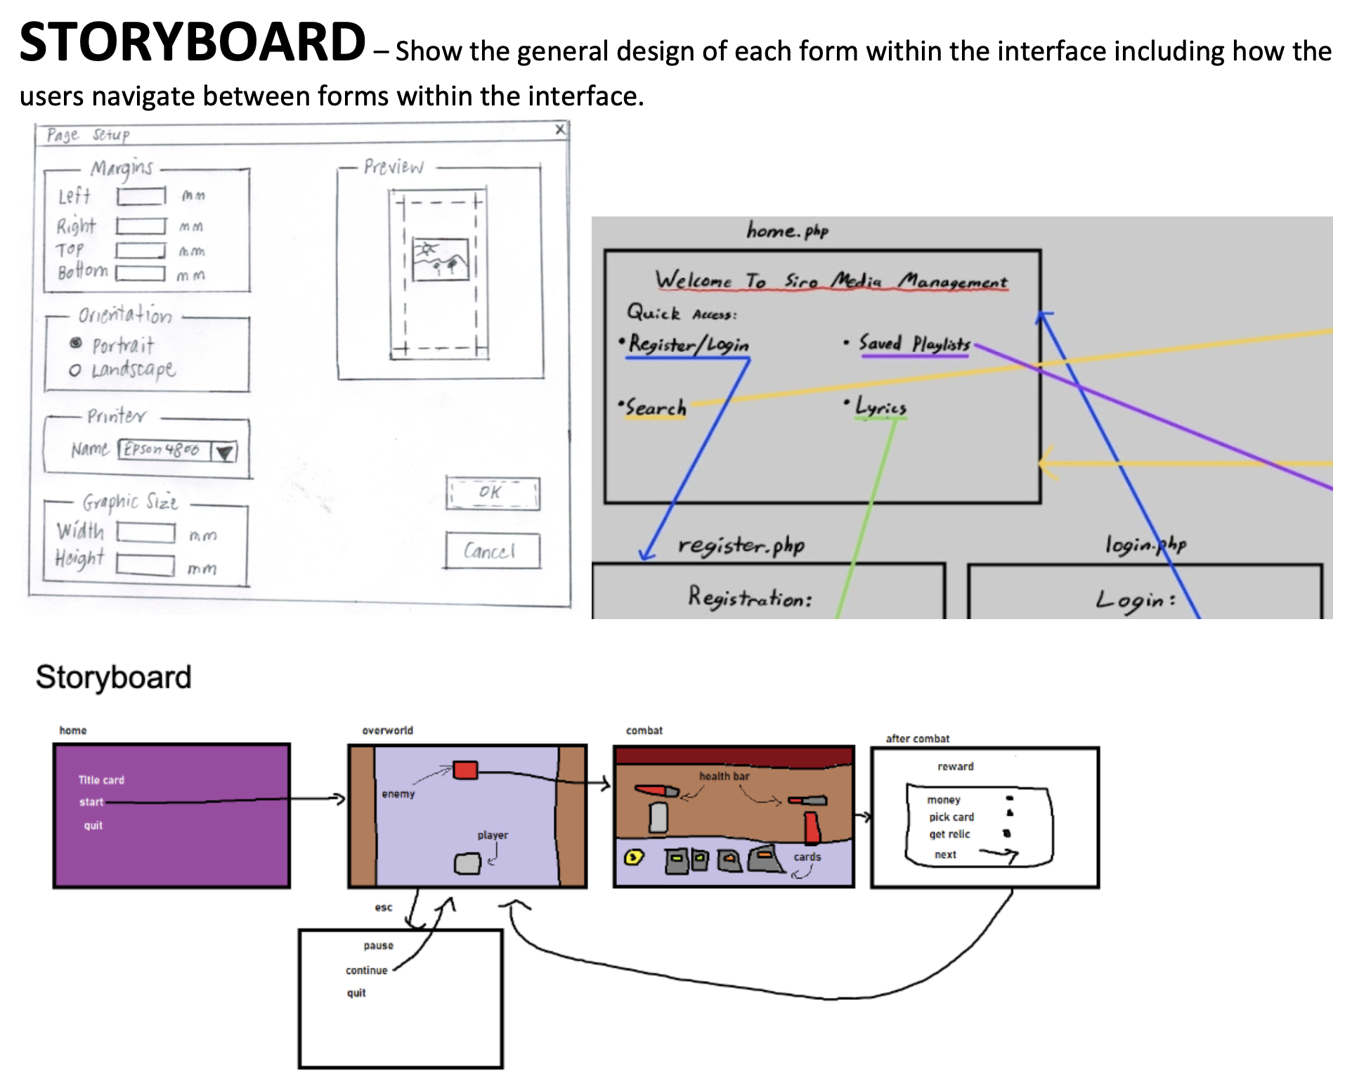

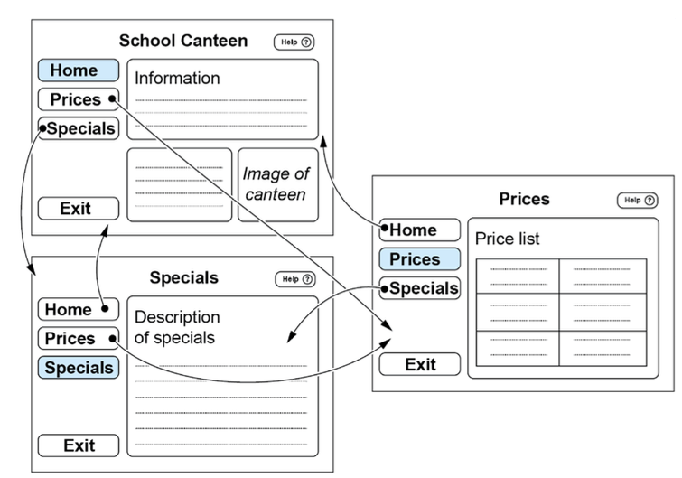

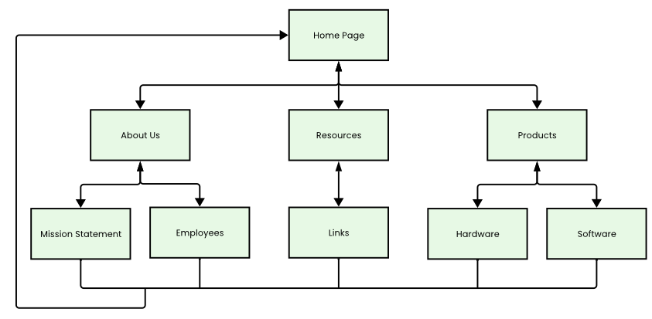

My Site Map

**Pseudocode/Flowcharts**

* For the main processing routines ONLY

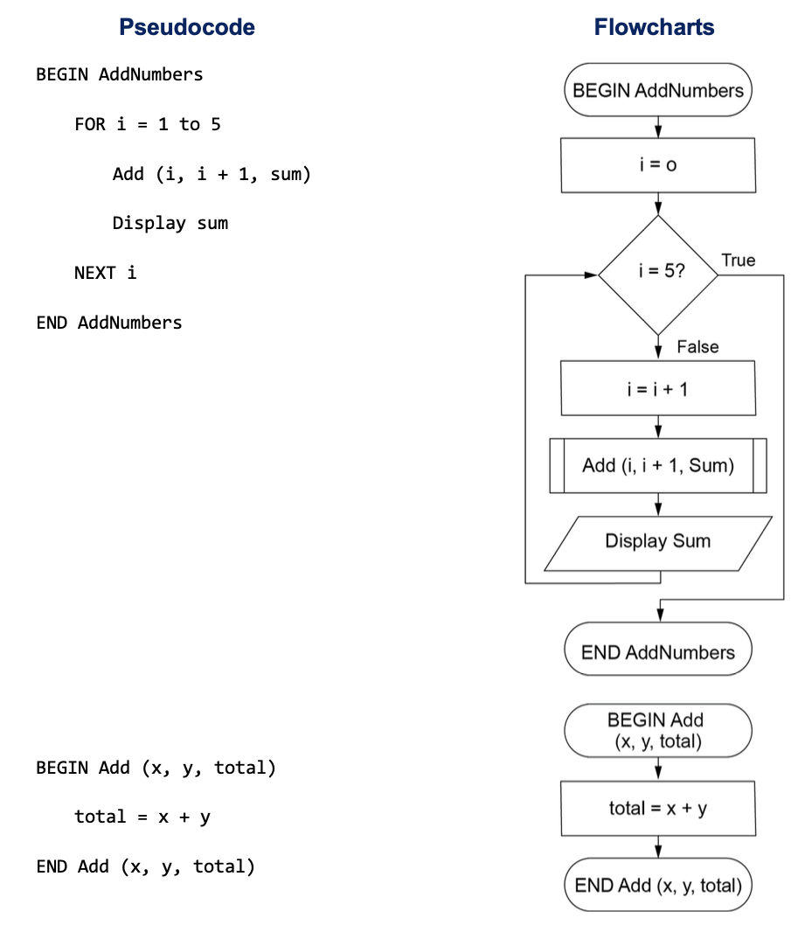

**Database Schema**

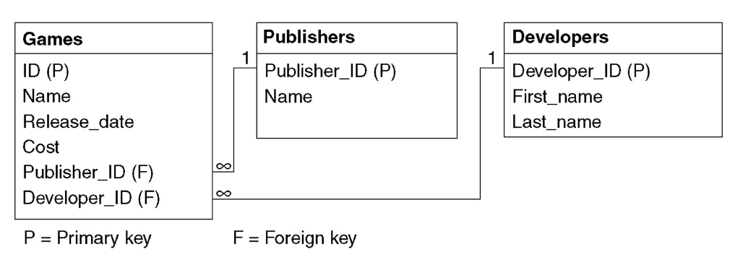

**Data Dictionary (**ONLY for the key variables in my project)

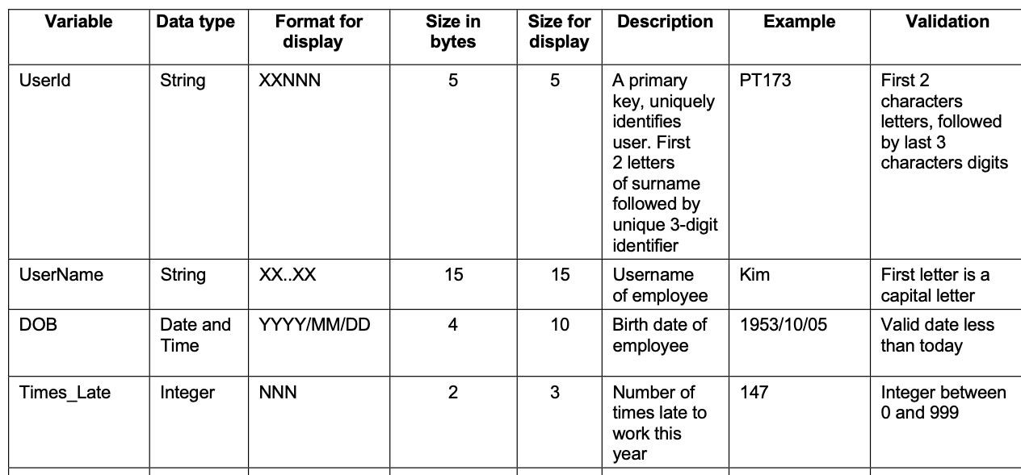

**IMPLEMENTATION/TESTING**

**Code Optomisation** - *An example of code optomisation from my project …*

**Test cases** - *Test cases considered …*

White/grey/black box analysis, ‘boundary’ values

Show consideration of automated test tools …

**PROJECT LOG**

* Record of all design decisions, history of completing this project

| **Date** | **Description of Issue/Event** |
| --- | --- |
| Wednesday 2nd April | Start of Logbook  Started brainstorming ideas. Thought about an e-commerce site to sell e-sims. This site is going to have a wide range of electronic SIM cards available in a multitude of countries, ranging from 5 GB to unlimited data. |
| Thursday 3rd April | Review the specifications and requirements.  Initial research - After comparing some eSIM websites, I concluded that I want my site to be based on a one-time purchase where you will choose the number of days that you want the eSIM to be active and the amount of data you would like to have during those days. |
| Friday 4th April | We reviewed schema ideas involving the “receipt” system and built a rough idea of how to link everything together. |
|  |  |
|  |  |
|  |  |
|  |  |
|  |  |
|  |  |